T01 (a): Build Appliance Energy Consumption website
Website: https://cos-30045-data-visualisation-jade.vercel.app/
T01 (b): Data Processing with KNIME
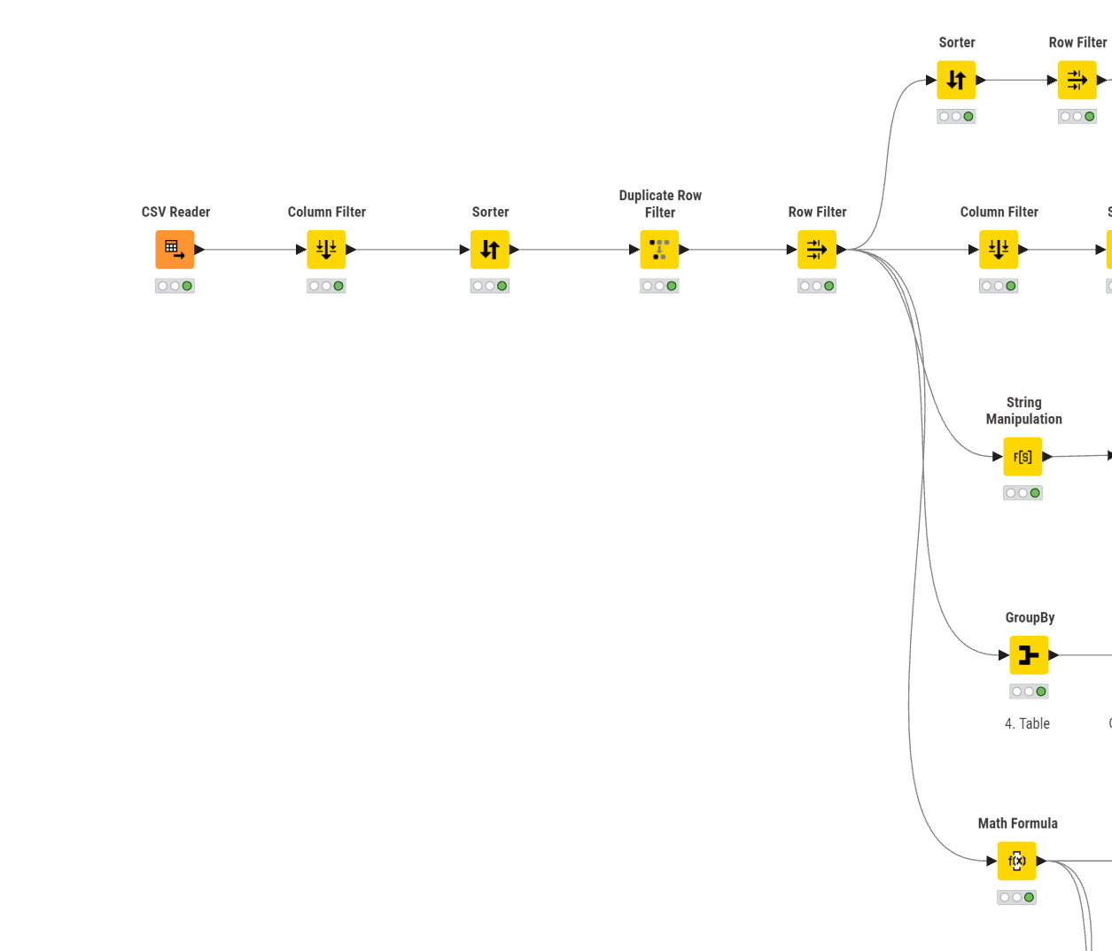

T02: Data Exploration and Basic Chart Types
- What type of TV screen technologies are currently available in Australia and which are the most frequent?
  - What data is needed to answer this question?
Column Name | Data Type | Description
Screen_Tech | String | The display technology used by the TV (e.g., LCD, LCD (LED), OLED).
Availability Status | String | The market status of the TV (Available or Unavailable).
SoldIn | String | The countries where the TV is sold (e.g., Australia).
Submit_ID | Integer | Unique Identifier
  - What chart type would be good to represent this data and give some reasons?
Bar Chart
Reason: Bar chart offer a more distinct difference between Screen_Tech category. It is more readable compare to using pie chart.
  - Draw a sketch of the chart
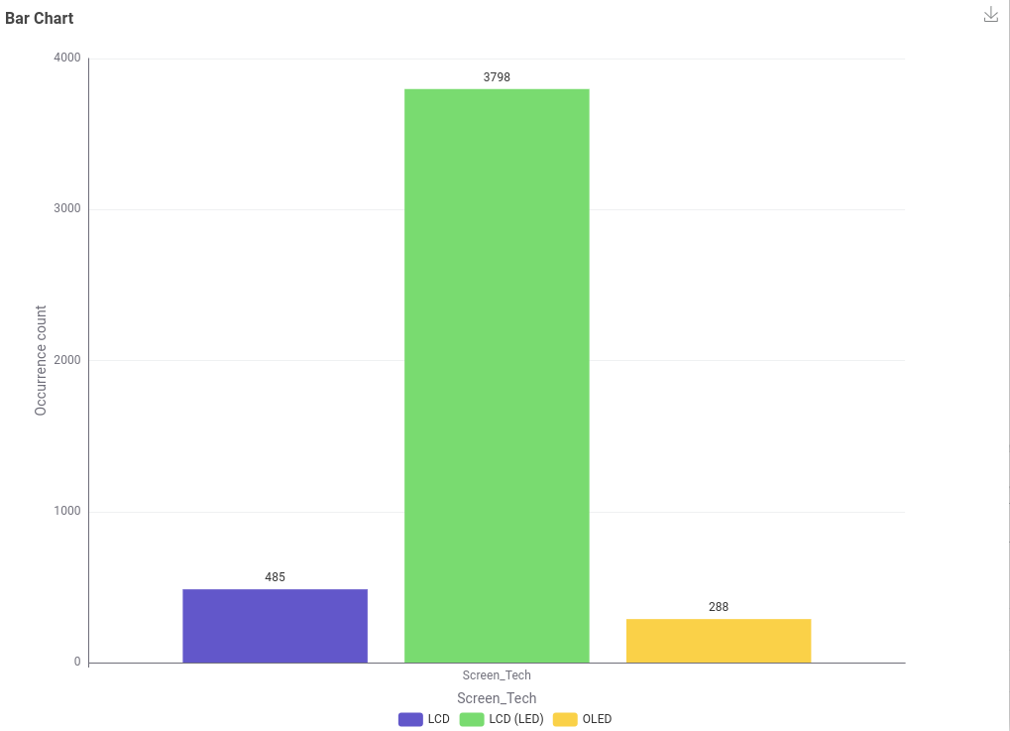

  - Draw a sketch of the data table required to build the chart
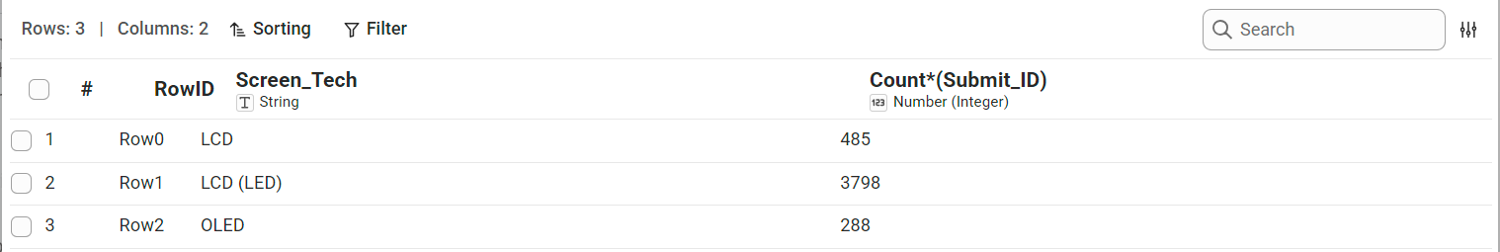

2. What screen sizes are currently available, and which are the most frequent?
  - What data is needed to answer this question?
Column Name | Data Type | Description
Screen size (inches) | Float | The physical diagonal measurement of the display screen, specified in inches.
Screen size (inches) -> count | Integer | The total number of records (frequency of occurrence) for that specific screen size in the dataset.

  - What chart type would be good to represent this data and give some reasons?
Bar Chart
Reason: There are many different screen size variant across the data. Using Bar Chart to view is much clearer because bar chart is the most effective choice for this data because it provides an immediate, accurate comparison of counts across multiple discrete categories.
  - Draw a sketch of the chart
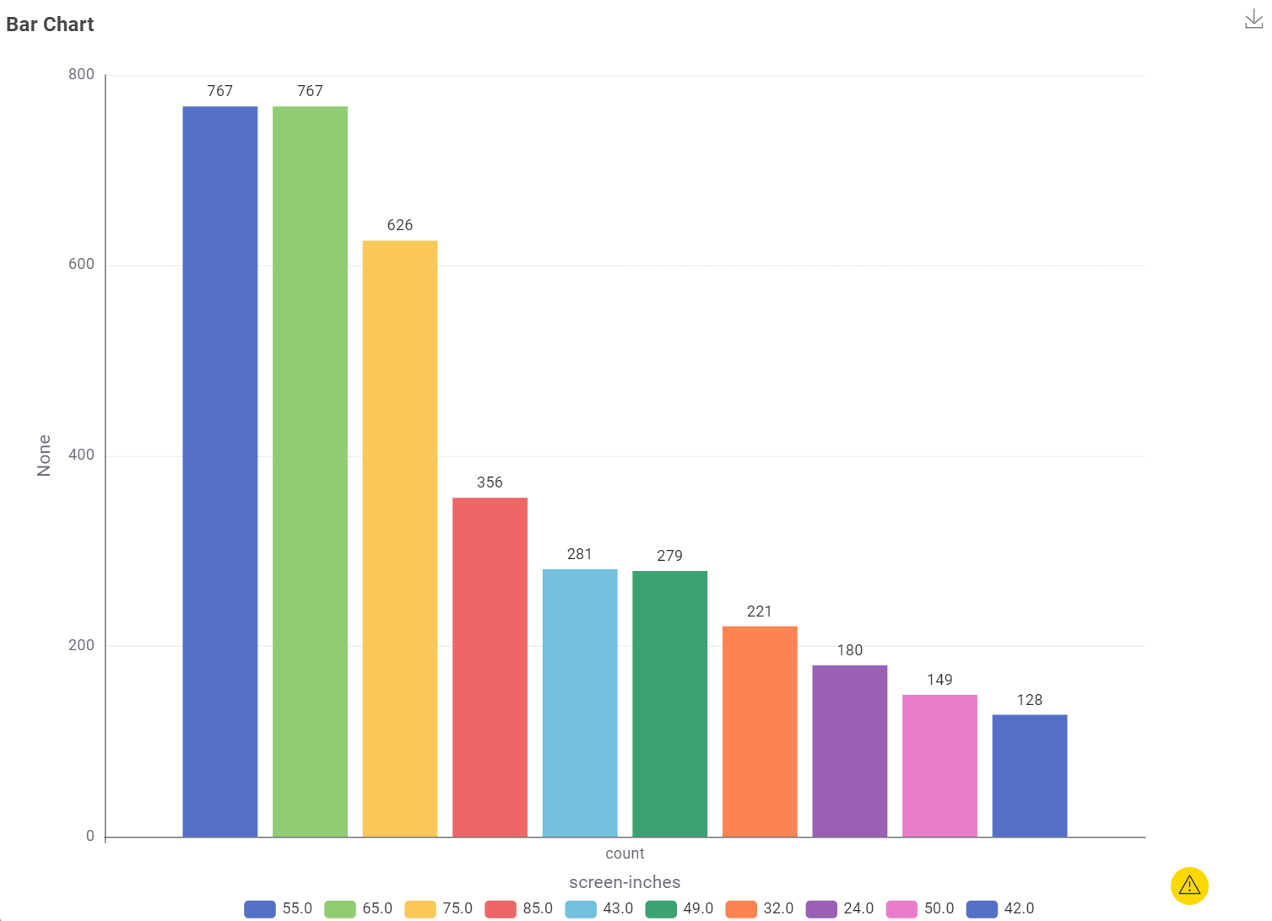

  - Draw a sketch of the data table required to build the chart
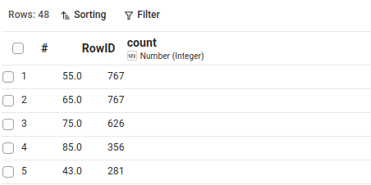

Screen size currently available: 16.0, 18.0, 19.0, 21.0, 22.0, 23.0, 24.0, 27.0, 30.0, 31.0, 32.0, 34.0, 38.0, 39.0, 40.0, 41.0, 42.0, 43.0, 46.0, 48.0, 49.0, 50.0, 54.0, 55.0, 56.0, 57.0, 58.0, 60.0, 64.0, 65.0, 67.0, 69.0, 70.0, 74.0, 75.0, 76.0, 77.0, 78.0, 82.0, 83.0, 85.0, 86.0, 88.0, 97.0, 98.0, 100.0, 114.0, 116.0

Which are the most frequent: 55 and 65 inch are the most frequent

3. Which brands have the greatest number of different models?
  - What data is needed to answer this question?
Column Name | Data Type | Description
Submit_ID | Integer | A unique numerical identifier assigned to each individual record or survey submission.
Brand_Reg (Lowered case) | String | The standardized brand name recorded in lowercase text to ensure consistent grouping and accurate count aggregation.
  - What chart type would be good to represent this data and give some reasons?
Pie Chart
Reason: A pie chart clearly visualizes how each brand's share contributes to the total (100%) volume of submissions. Pie chart also effectively consolidate category because smaller brands are grouped into an "Other" segment, the chart maintains a clean, readable number of slices without visual clutter.
  - Draw a sketch of the chart
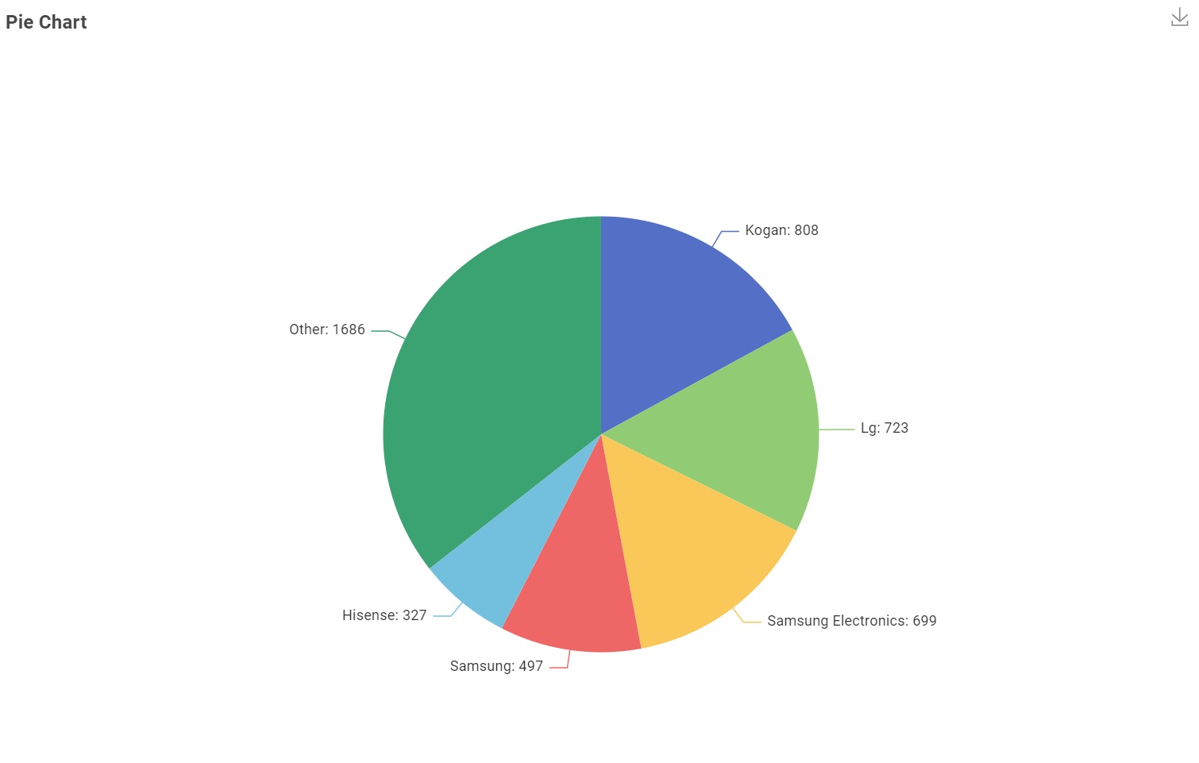

  - Draw a sketch of the data table required to build the chart
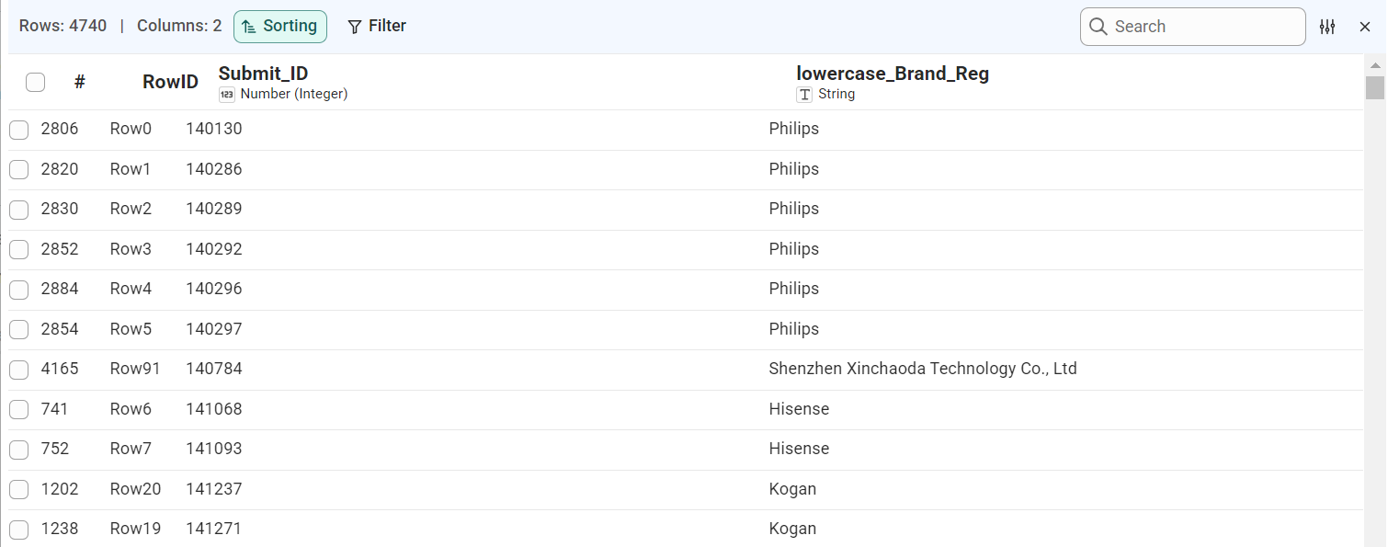

Answer: Kogan with 808 (17.05%) model

4. Which type of screen technology consumes the least amount of power?
  - What data is needed to answer this question?
Column Name | Data Type | Description
Screen_Tech | String | The categorical display technology used by the screen (e.g. LCD, LED, OLED).
Avg_mode_power -> median | Float | The median continuous power consumption (in watts) measured across devices within each screen technology category.
  - What chart type would be good to represent this data and give some reasons?
Bar Chart
Reason: A bar chart is ideal because it compares a continuous numerical metric (median power consumption) across discrete, independent categories (screen technologies). Aligning the bars along a common baseline makes difference in magnitude immediately obvious and allows for an intuitive, direct visual ranking from lowest to highest power usage.
  - Draw a sketch of the chart
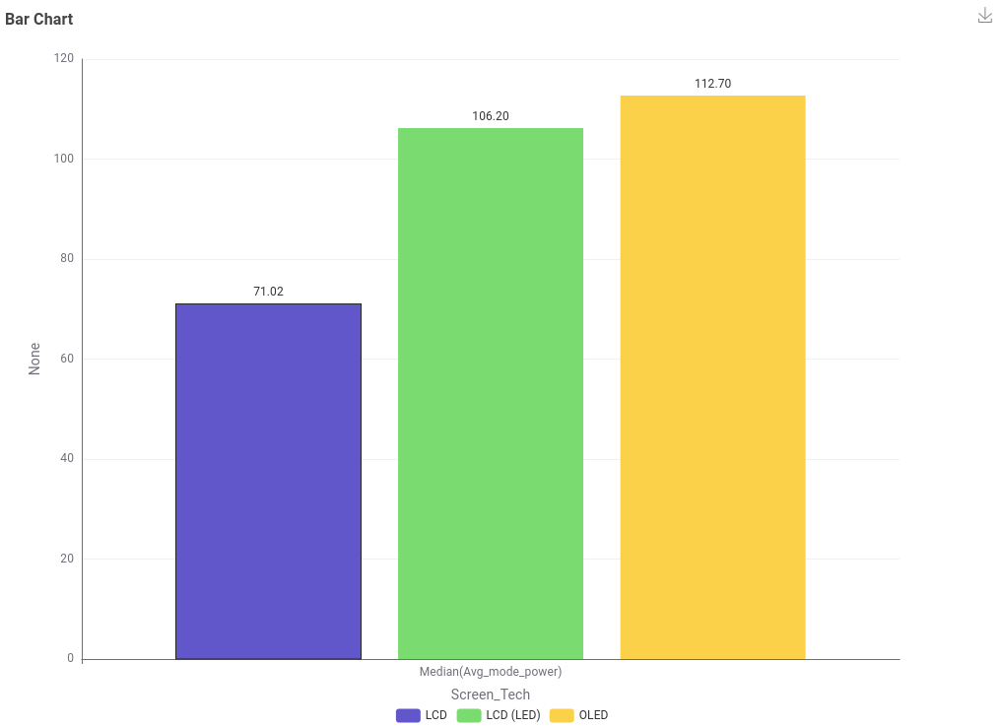

  - Draw a sketch of the data table required to build the chart
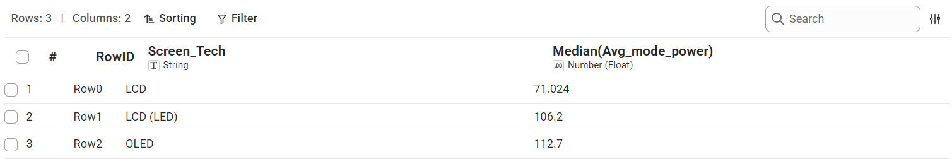

Answer: LCD with the median of 71.02 mode power

5. What is the relationship between screen size and power use?
  - What data is needed to answer this question?
Column Name | Data Type | Description
Avg_mode_power | Float | The continuous numerical value representing average power consumption in on-mode.
screensizes -> inches | Float | The physical diagonal display dimension of each screen measured in inches.
  - What chart type would be good to represent this data and give some reasons?
Scatter Plot Chart
Reason: A scatter plot is the ideal choice because both variables are continuous numerical data, making it effective for displaying the correlation and relationship between screen size and power consumption. It clearly reveals overall trends such as power usage increasing non-linearly with screen area while preserving individual data points to highlight variance, clusters around standard screen sizes, and potential outliers.
  - Draw a sketch of the chart
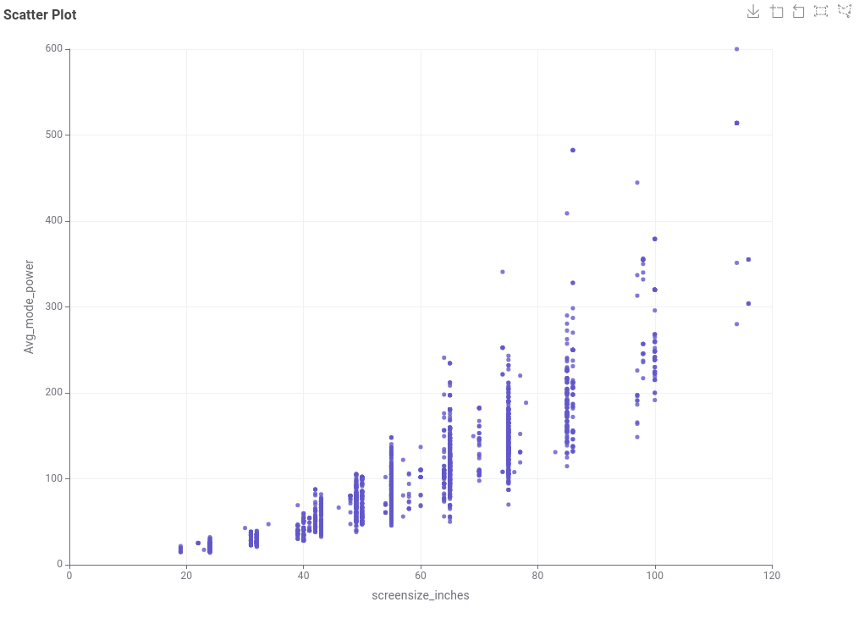

  - Draw a sketch of the data table required to build the chart
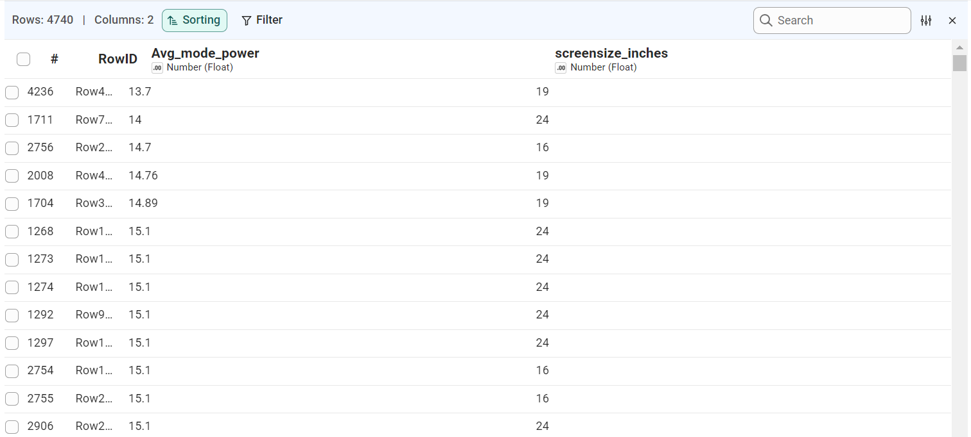

Answer: The larger the screen size, the higher the power use.

6. What is the relationship between star rating and screen size?
  - What data is needed to answer this question?
Column Name | Data Type | Description
Star Rating Index | Float | A continuous numerical score indicating the energy efficiency rating or performance index of the screen.
screensizes -> inches | Float | The physical diagonal display dimension of each screen measured in inches.
  - What chart type would be good to represent this data and give some reasons?
Scatter Plot Chart
Reason: A scatter plot is well suited for examining the potential relationship or correlation between two continuous variables (screen size and star rating index). It plots each screen as an individual coordinate, clearly demonstrating the distribution, density, and whether energy efficiency ratings systematically vary with physical display size.
  - Draw a sketch of the chart
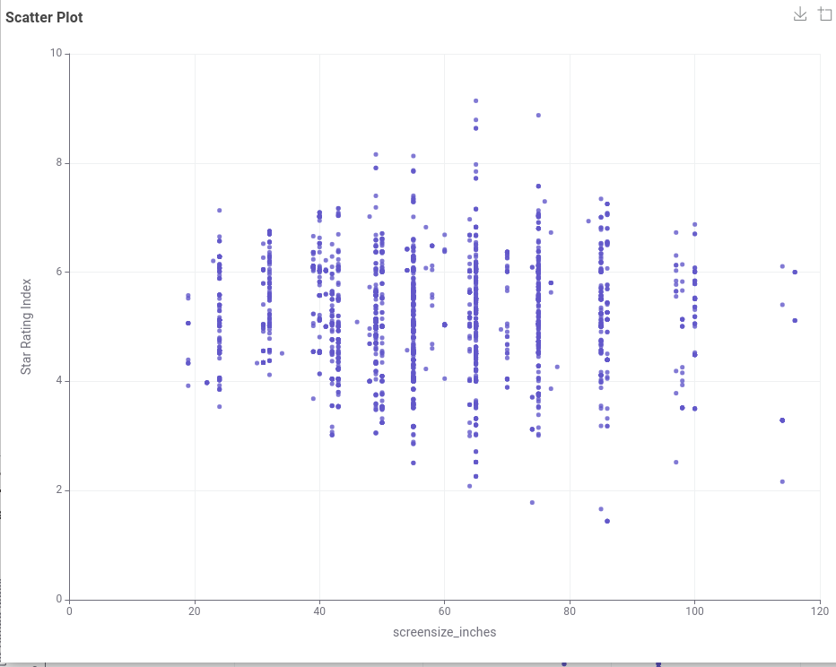

  - Draw a sketch of the data table required to build the chart
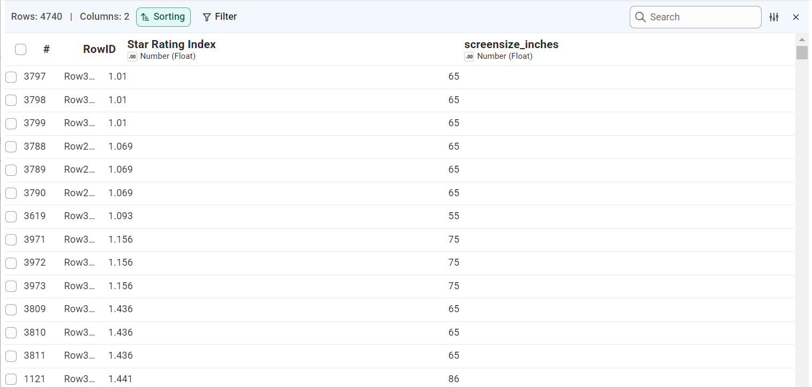

Answer: Based on the data analysis, it doesn’t show any relationship or linear correlation between screen size and star rating. A larger TV screen does not systematically result in a higher or lower Star Rating index.

[optional] Are there differences in power consumption between brands?
  - What data is needed to answer this question?
Column Name | Data Type | Description
Brand_Reg (Lowered case) | String | The standardized brand name recorded in lowercase text to ensure consistent grouping and accurate count aggregation.
Avg_mode_power | Float | The continuous numerical value representing average power consumption in on-mode.
  - What chart type would be good to represent this data and give some reasons?
Scatter Plot Chart
Reason: A scatter plot (strip plot) effectively displays the full distribution of a continuous numerical variable (Avg_mode_power) across discrete categorical groups (Brand_Reg). By plotting every individual model as a distinct point along each brand's column, it highlights the range, spread, density clusters, and extreme high-power outliers within each brand rather than hiding variance behind a single average.
  - Draw a sketch of the chart
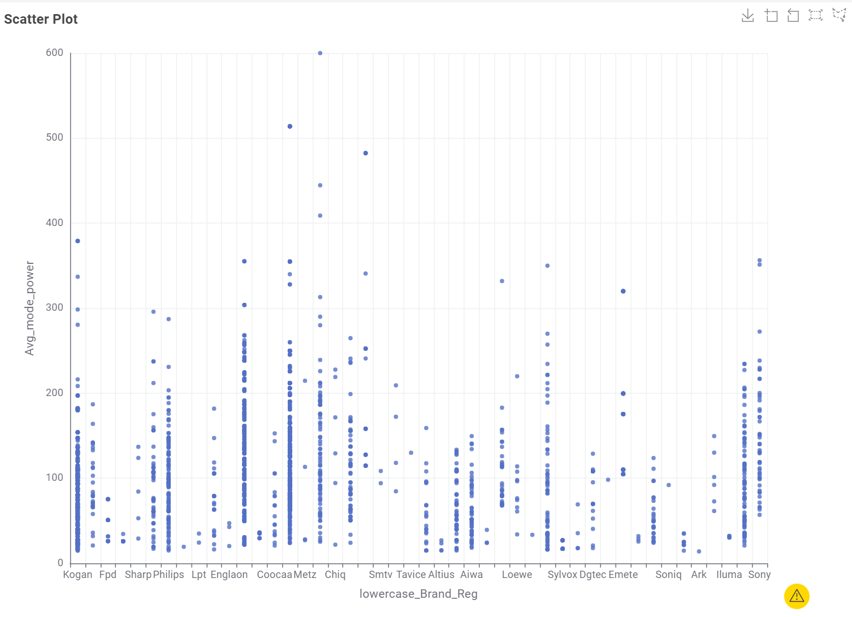

  - Draw a sketch of the data table required to build the chart
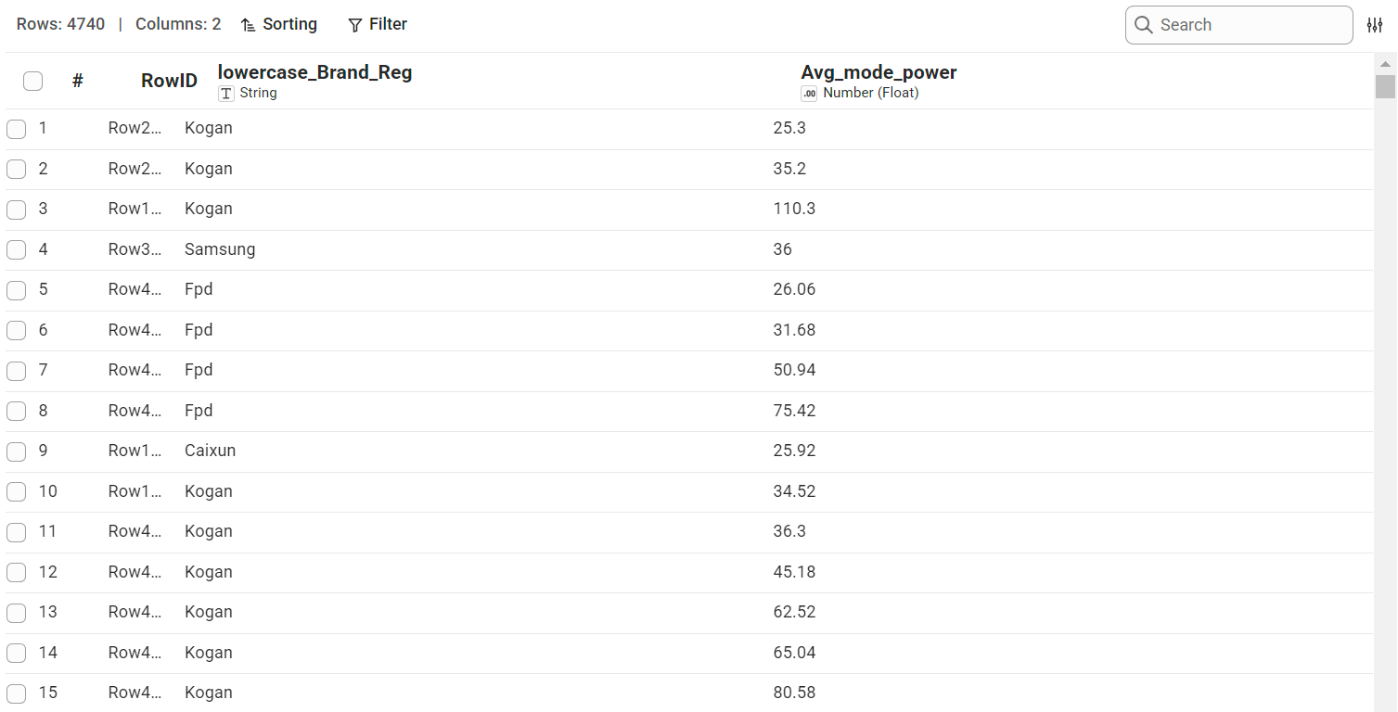

Answer: The differences show no relationship between power consumption and brands.

T03: Communicating Data Insights
- Link to your Miro boardLinks to an external site. showing the storyboard for answering the 6 questions

